
Maintenance, test and support of multimedia software to S60 platform program and product programs

Date 2008-06-17
Status Proposal
CONFIDENTIAL
Embedded Software Division
Neusoft Group Ltd.

1 History 3
2 Project Overview 3
2.1 Objectives 3
2.2 Project Description 3
2.3 Features 3
2.4 Project Ramp-Up Schedule 3
2.5 Project Cost 3
2.6 Project Deliveries 3
3 HR Ramp up Plan 3
4 Roles and responsibilities 3
4.1 Project Organization(Neusoft) 3
4.2 Roles and teams 3
4.3 Reporting and Meetings 3
4.3.1 Steering Group 3
4.3.2 Project Meeting 3
5 Ways of working approach 3
5.1 Documentation 3
5.2 Working Process 3
5.2.1 Bug Fixing Process 3
5.2.2 Source code check in process 3
5.3 Tools and facilities for project work 3
5.3.1 Hardware 3
5.3.2 Software 3
5.3.3 Current available in NEUSOFT 3
5.3.4 Network Environment 3
5.3.5 Source code management 3
5.3.6 General Situations of Neusoft development work 3
6 Quality Targets and Metrics 3
7 Risk Management 3
8 Capability & Similar Experience 3

History
Version | Date | Reason for Changes
0.1 | 2008.2.29 | Draft
0.2 | 2008.3.4 | Add summary of the experience and skills
0.9 | 2008.3.10 | Update
0.95 | 2008.6.9 | Update
1.0 | 2008.6.17 | Review and Approve
1.3 | 2008.6.26 | Update and Review

Project Overview

Objectives

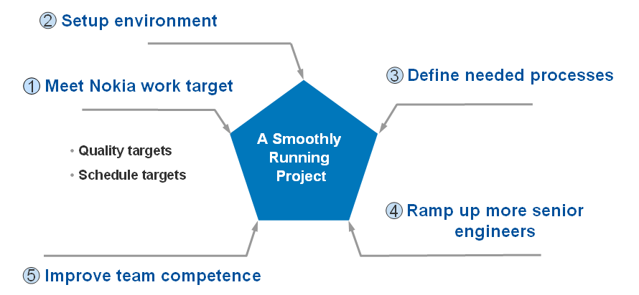

In the beginning, Neusoft will deliver the Quality Target as well as Schedule Targets after fully study the NOKIA SOW and relevant documentation with last experience. NOKIA need to go through them and give the feedback back and forth. Finally mutual reach the common consensus on it.

Secondly, Neusoft is about to prepare the work environment in test house based on the inputs provided by NOKIA and operator customer including development and testing environment, HW and SW procurement and installation and so on. And turn in the process report timely when each item is established well.

Meanwhile, the necessary high efficient process should be set up in mutual preparation period in terms of communication way, daily work flow, processes and like that.

After that, more seasoned and competent senior engineers will be bring up and recruited soon. All relevant training courses will be implemented timely to ensure them more experienced.

Also, the core team will sort out all the needed knowledge, relevant materials making a training course designed. As the project goes forward, more and more valuable technical and experience will be added into the training course, all the member can participate inner sharing meeting to get the most recent technical.

Project Description
The project work scope is the maintenance, test and support of multimedia software to S60 platform program and product programs.Neusoft provides developing and testing service for multimedia software based on S60 platform.

2.2.1 Networked Media App[Video Center]
The task list for this project as below:
- Error Triage
  - reproduce error according to report,
  - analyze error by taking logs to better understand failure
  - assign defect report to the appropriate SW Technology Area team
- Error Investigation & Resolution
  - propose error fix and submit for code review
  - make code changes, integrate and check-in to CM-Synergy
  - track various SW build environments, integrate, verify & release in configuration management
  - provide documentation on the code changes
  - perform code review for the error fix with the development team
  - check-in the error fix
- Test
  - participate in reproducing the reported error
  - verify proposed & released fix
  - create test cases if needed
  - run functional, regression, exploratory and ad-hoc testing

2.2.2 Mobile TV
The task list for this project as below:

- Testing Environment preparation
  - Small amount of resources from the beginning to prepare all the environments and infrastructure for future maintenance of Mobile TV application
  - Set up environment(s) for DVBH and other bearers（Suppose NOKIA is responsible for setting up the environment(s) for DVBH and other bearers）
- Error Triage
  - reproduce error according to report,
  - analyze error by taking logs to better understand failure
  - assign defect report to the appropriate SW Technology Area team
- Error Investigation & Resolution
  - propose error fix and submit for code review
  - make code changes, integrate and check-in to CM-Synergy
  - track various SW build environments, integrate, verify & release in configuration management
  - provide documentation on the code changes
  - perform code review for the error fix with the development team
  - check-in the error fix
- Test
  - participate in reproducing the reported error
  - verify proposed & released fix
  - create test cases if needed, as well as STIF Test cases
  - run functional, regression, exploratory and ad-hoc testing

2.2.3 Video Player & Automate Test(MPX, MTP, MP)
The task list for this project as below:

- Test
  - participate in reproducing the reported error
  - verify proposed & released fix
  - develop Automation test script in terms of: IAD test, Regression Test, System Test, Performance Test.
  - run functional, regression, exploratory and ad-hoc testing

2.2.4 Audio Application and Symbian MTP migration
The task list for this project as below:

- Error Triage
  - reproduce error according to report,
  - analyze error by taking logs to better understand failure
  - assign defect report to the appropriate SW Technology Area team
- Error Investigation & Resolution
  - propose error fix and submit for code review
  - make code changes, integrate and check-in to CM-Synergy
  - track various SW build environments, integrate, verify & release in configuration management
  - provide documentation on the code changes
  - perform code review for the error fix with the development team
  - check-in the error fix
- Test
  - participate in reproducing the reported error
  - verify proposed & released fix
  - create test cases if needed
  - run functional, regression, exploratory and ad-hoc testing

Features
Multimedia application as the S60’s Core Software with the following features:
- Audio streaming
- Video streaming
- local audio/video playing
- Supporting protocol:RTP/RTCP/RTSP/HTTP
- DVBH
- FM Radio, Voice Recorder, Metadata
- Supporting media content type: AMR, AAC, H.264, MPEG4, H.263, WM

Project Ramp-Up Schedule

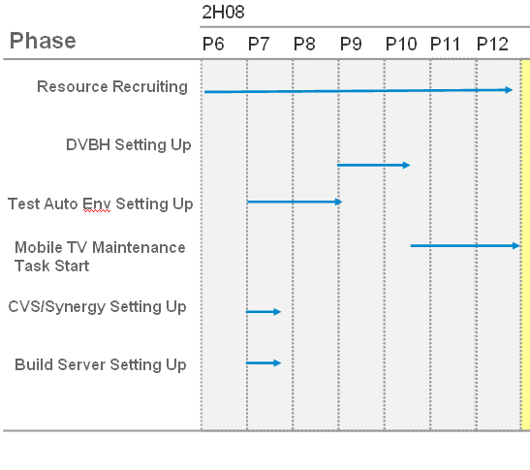

At the beginning, all the projects will get started in terms of Testing environment, CVS/Synergy strategy, Build Server establishment. In the middle period of July, all will be well-prepared. As our estimated, the Test Auto Environment and related technical can be master by the end of August or earlier.

Starting from September, the DVBH environment should be initiated until middle of October. The following, Mobile TV task can start as scheduled.

Note: Test plan will follow Nokia test plan

Project Cost
The price list between Neusoft and Nokia is as bellow:

Category | Beijing 2007 price in EUR | Beijing 2007 price  in CNY | Beijing 2008  Price  in EUR | Beijing 2008  Price  in CNY | Chengdu price  in EUR | Chengdu  Price  in CNY
Development Project Manager | 15.83 | 172.5 | 15.83 | 172.5 | 14.2 | 154.78
Specialist,  Senior Designer,  Test Project Manager | 13.56 | 147.86 | 13.56 | 147.86 | 12.2 | 132.98
Designer,  SeniorTest Engineer,  Test Team Leader | 11.3 | 123.21 | 11.3 | 123.21 | 10.2 | 111.18
Test Engineer | 9.95 | 108.43 | 9.5 | 103.55 | 7.7 | 83.93
Trainee,  True tester | 5 | 54.2 | 4.8 | 51.8 | 3.9 | 42

So from July. 1 to Dec. 31, the Maximum Cost is about 400,615.76 EUR (Note: Maximum Cost is adding 15% of the man-day cost for the purpose of OT Work based on normal man-day cost.) . Neusoft will charge accoding to actual workload.
Refer to the excel:
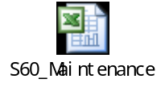

Project Deliveries
2.6.1 Networked Media App[Video Center]

Following work production will be submited to Nokia:

- Project plan
- Bug fixing
- Source code for multimedia software
- Created test cases and test report
- Defect analysis report
- Weekly report
- Error correction

2.6.2 Mobile TV

Following work production will be submited to Nokia:

- Project plan
- Bug fixing
- Source code for multimedia software
- Error correction
- Created test cases and test report
- Defect analysis report
- Weekly report

2.6.3 Video Player & Automate Test(MPX, MTP, MP)
Following work production will be submited to Nokia:

- Project plan
- Created test cases and test report
- Automation Test Script
- Defect analysis report
- Weekly report

2.6.4 Audio Application and Symbian MTP migration
Following work production will be submited to Nokia:

- Project plan
- Bug fixing
- Source code for multimedia software
- Created test cases and test report
- Defect analysis report
- Weekly report
- Error correction

HR Ramp up Plan
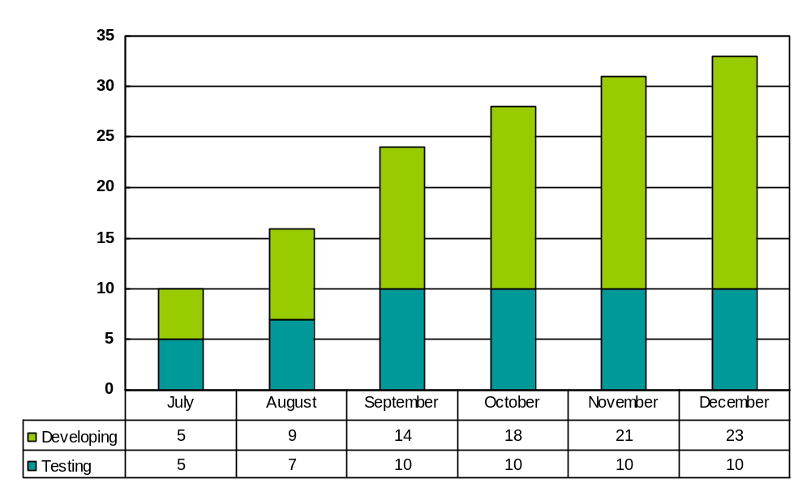Neusoft will build up the team according to following schedule. The team will be built up at the beginning of June.

Distribution By Project
Sub Team | Planned Effort  of 2H08  Man.months | P7 |  | P8 |  |  | P9 |  |  |  | P10 |  |  |  | P11 |  |  |  | P12
Sub Team | Planned Effort  of 2H08  Man.months | D | T | D | SD | T | D | SD | T | ST | D | SD | T | ST | D | SD | T | ST | D | SD | T | ST
Networked  Media App | 20 | X | x | x | x | x | 2 | 0 | 0 | 0 | 4 | 0 | 0 | 0 | 5 | 1 | 0 | 0 | 7 | 1 | 0 | 0
Mobile TV | 14 | X | x | x | x | x | 1 | 0 | 1 | 0 | 2 | 1 | 1 | 0 | 2 | 1 | 1 | 0 | 2 | 1 | 1 | 0
Multimedia  Players* | 30(Maintenance  of Audio App) | 1 | 1 | 2 | 1 | 1 | 4 | 1 | 1 | 0 | 4 | 1 | 1 | 0 | 4 | 1 | 1 | 0 | 4 | 1 | 1 | 0
Multimedia  Players* | 24(Symbian MTP migration) | 2 | 0 | 3 | 1 | 0 | 3 | 1 | 0 | 0 | 3 | 1 | 0 | 0 | 4 | 1 | 0 | 0 | 4 | 1 | 0 | 0
Multimedia  Players* | 30(VPMaintenance  Testing&Auto-Test) | 0 | 2 | 0 | 0 | 4 | 0 | 0 | 5 | 1 | 0 | 0 | 5 | 1 | 0 | 0 | 5 | 1 | 0 | 0 | 5 | 1
Multimedia  Players* | 24(TestAutomation Development) | 2 | 2 | 2 | 0 | 2 | 2 | 0 | 2 | 0 | 2 | 0 | 2 | 0 | 2 | 0 | 2 | 0 | 2 | 0 | 2 | 0
Total: | 142 | 5 | 5 | 7 | 2 | 7 | 12 | 2 | 9 | 1 | 15 | 3 | 9 | 1 | 17 | 4 | 9 | 1 | 19 | 4 | 9 | 1
- D: Developer/Designer;
- SD: Senior Developer/Designer;
- T: Tester
- ST: Senior Tester

All project candidates will join following training:

- Neusoft/Nokia Project process
- Symbian/S60 UI style, S60 Design Template etc
- NOKIA multimedia Video, Voice, MP framework
- Software tools: Carbide/CodeWarrior, Synergy, TSW, QC(tester joined)

Neusoft need Nokia provide some project document and source code after the NDA has been signed so that Neusoft can arrange code analysis before project starts.

Roles and responsibilities

Project Organization(Neusoft)
- Networked Media App

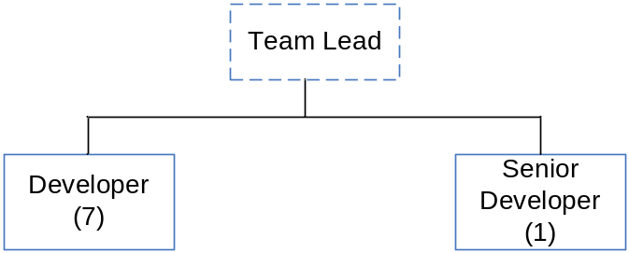

- Mobile TV

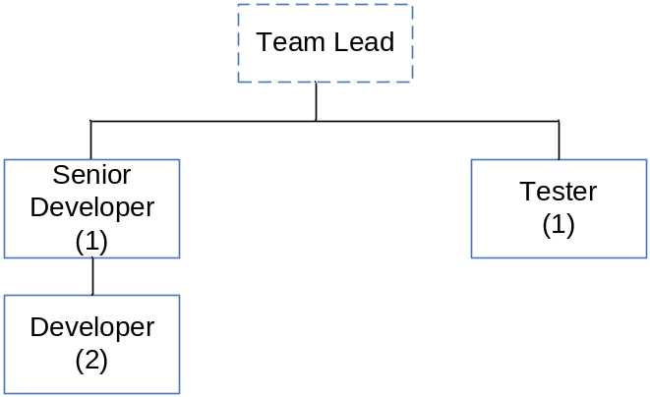

- Video Player & Automate Test(MPX, MTP, MP)

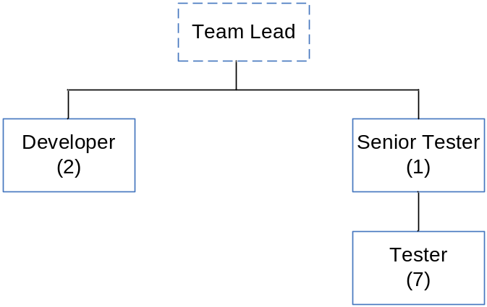

- Audio Application and Symbian MTP migration

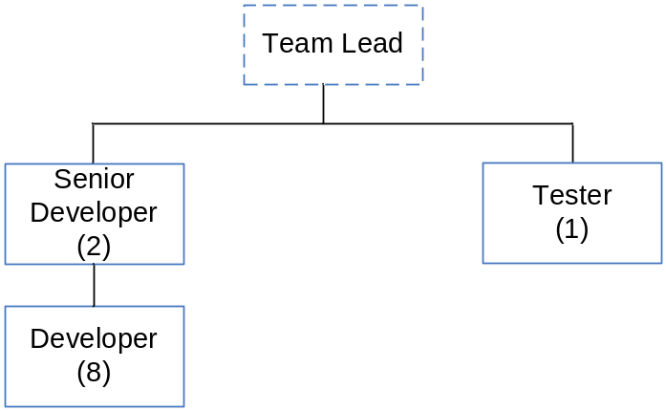

Roles and teams

Team Lead is responsible for communicate with Nokia, reviewing internal codes changed for the error and ramping up the team members. Team Lead are also act as a senior developer/tester in the aboving projects.
Software Engineer is responsible for the investigating errors and fixing errors for multimedia software.
Test Engineer is responsible for creating test cases, running test cases and submit testing report

Reporting and Meetings

Steering Group
From Nokia:
Contract Issues (From CMO) | Name: perttu.hietal  Mail: perttu.hietala@nokia.com
Project Issues: | Name: Simon Khoo  Mail: Simon.Khoo@nokia.com
From Neusoft:
Contract Issues: | Name: Peter Qu  E-mail: Ext-bintao.qu@nokia.com  Phone:+86-10-82777786  Mobile:+86 1391 113 71541
Project Management Issues | Name: Zhao Ming /David Tian  E-mail: ext-ming.2.zhao@nokia.com  ext-david.tian@nokia.com

Project Meeting
Project meetings are the major method to monitor the project work. They shall be held regularly, preferably monthly
The Subcontractor shall furnish Nokia with agenda, reports and documents to be handled and reviewed in the meeting at least one week before it.
The results and the actions from the meeting shall be recorded.
Following meetings will be arranged to ensure quality output of the project.
- General project meeting
Communicate with NOKIA when important event appears or at the time point of milestone, to do reporting, receive orders, make or change important decisions.
- Review meetings
Review meetings will be arranged every week and go through major shortcomings. Meetings minutes will be taken in MS-Word format.
- Intramural weekly Meeting
Team leader will hold a weekly meeting in order to know the problems blocked project from team members.
- Weekly progress report
Team leader shall provide written weekly report to Nokia project manager. This report shall contain following information:
- General description of the project situation
- A description of changes and their impact on the project
- A description of the activities to be performed during the next week
- A list of problems / risks / change needs and their possible impact on the schedule

Ways of working approach

Documentation
Following documents need to be delivered to Neusoft:
5.1.1 Networked Media App[Video Center]
- Final Release Code
- Design Documents
- Template for error collection & error reporting
- Video framework

5.1.2 Mobile TV
- Final Release Code
- Design Documents
- DVHB testing environment specification
- Template for error collection & error reporting

5.1.3 Video Player & Automate Test(MPX, MTP, MP)
- Design Documents
- Template for error collection & error reporting
- Video, MPX, MTP, MP Framework Specification
- Automation Test script handbook

5.1.4 Audio Application and Symbian MTP migration
- Final Release Code
- Design Documents
- Template for error collection & error reporting
- Audio application framework

Working Process
Neusoft defined following process for this project

5.2.1 Bug Fixing Process
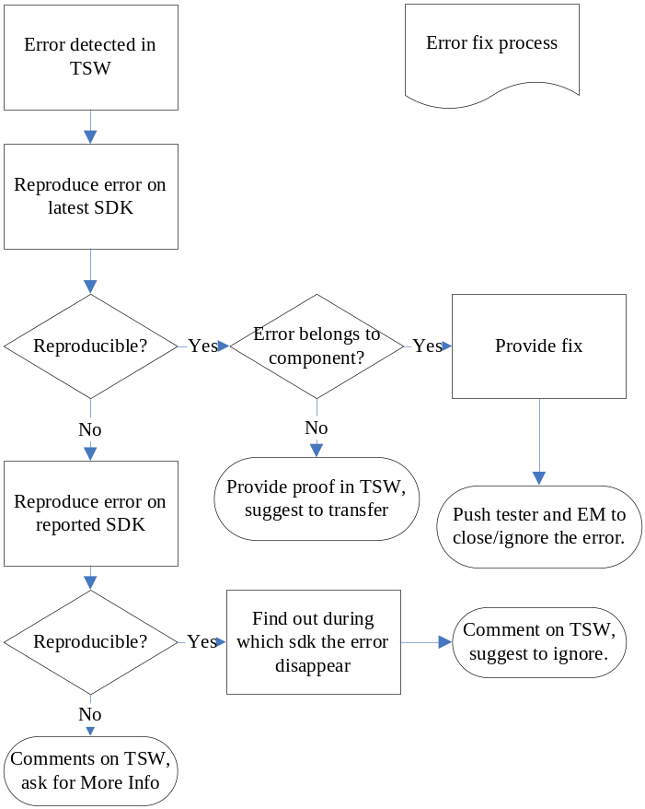

5.2.2 Source code check in process
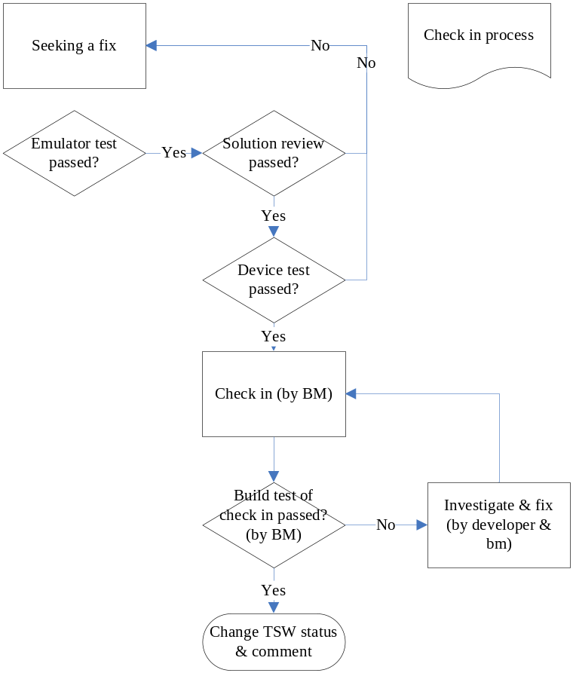

Tools and facilities for project work

Hardware
Nokia provides the terminals and corresponding SIM cards(according the Operators) to Neusoft.

Software
Neusoft will provide following software for this project
- Carbide/CodeWarrior
- RVCT
- Synergy client

Synergy Strategy
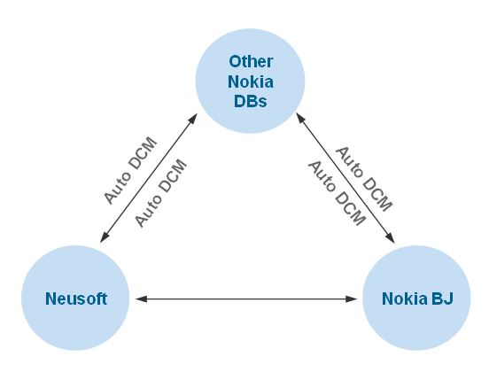

Nokia will provide
1. Networked Media App[Video Center]
- S60 SDK
- TSW
- QC

2. Mobile TV
- S60 SDK
- TSW
- QC

3. Video Player & Automate Test(MPX, MTP, MP)
- TSW
- QC
- STIF
- CodeScanner

4. Audio Application and Symbian MTP migration
- S60 SDK
- TSW
- QC

Current available in NEUSOFT
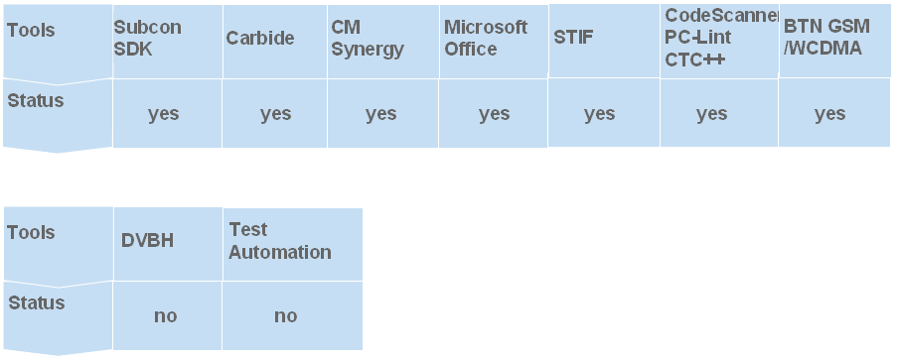

Network Environment
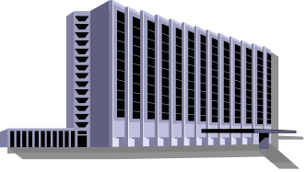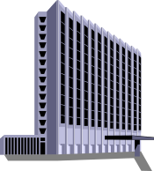
Neusoft Beijing
4M DDN for Data
Nokia Beijing
There is 4M DDN connected to Nokia extranet. Nokia 2G/3G base station has been already set up in Neusoft office. If the project need to use internal 2G/3G environment, Nokia will be responsible for provide NTN(Nokia Testing Network) cards for Neusoft.
Following Tools have been used in our current projects:
- Test Director/QC -- Filling the test results, based-web
- TSW – Error Database
- Synergy – Source code management

Source code management
Neusoft suggested to use Nokia Synergy to manage the source code. Nokia give the access right to Nokia Syngey system. Neusoft use Syngey client to access the source code.
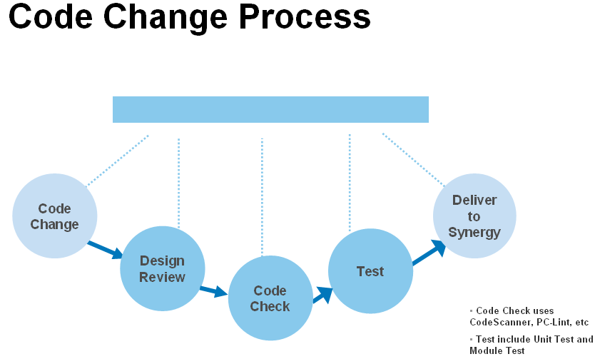

General Situations of Neusoft development work
For more info please refer to attachment: <<General Situations of Neusoft development work.doc>>
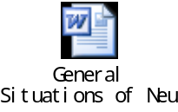

Quality Targets and Metrics
As this is an ongoing project, all these quality criteria and service levels will be applicable during the whole duration of this project.
The general quality criteria are for the multimedia software is the following:
- Error correction cannot cause regression in software
- No showstopper and major errors are allowed
- Planned test cases are executed = 100%
- Planned test cases are passed successfully >98% provided that all the functionalities are implemented in the terminals.
- Make code changes for Helix DNA Client, Neusoft needs the support of NOKIA’s developing team
- Review process---Code review, verification, test
- Error matrix analysis—collect during the project
- Change request

Risk Management
The are following risks in this project:
- Developers in Beijing has not enough experience
  - Neusoft will make a competence development plan for every new developer and arrange them to Neusoft other center to study.
  - Neusoft will arrange knowledge sharing activity between developing team and testing team which has experience on this are.
  - Nokia will also arrange two weeks training for Neusoft developers.
- Communication: Project working language is English, it is not mother language for Neusoft, so language barrier may cause misunderstanding or even problems.
  - Neusoft will arrange technical leader as interface in order to keep all requirement are understood.
  - All requirement will be documented
  - After face2face meeting or Tel-conference, if there are some decisions made.Neusoft will send meeting minutes to Nokia for confirming again all discussed issues. Voice Record may also be used during Tel-conference.
- Neusoft Employee Resignation /Dismission
  - Arrange backup engineers in this project
  - Any employee changes will inform Nokia before hand and backup engineer will move into team ASAP to replace

Capability & Similar Experience
    - Rich experiences with Nokia S60 platform/product maintenance working processes.
    - Experienced build managers and good Synergy usage skills.
    - Qualified develop & management experiences of S60 error fixing & CR/REQ implementing in PIM area.
    - Matured testing & developing statistics tracking & analyzing effort.
    - Performance-improvement oriented maintenance experiences (e.g. power consumption, startup time)
    - Agile development & maintenance experiences for Chinese specific features within S60 3.2 & 5.0 platform. (geared with Nokia agile mode in use)

